2. Foundations of American Government
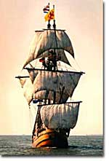
Sea travel expanded the horizons of many European nations and created prosperity and the conditions for the Enlightenment. In turn, the Enlightenment ideals of liberty, equality, and justice helped to create the conditions for the American Revolution and the subsequent Constitution.
__________was not created in a heartbeat. In a world where people were ruled by monarchs from above, the idea of self-government is entirely alien. __________ takes practice and wisdom from experience.
The American colonies began developing a democratic tradition during their earliest stages of development. Over 150 years later, the colonists believed their experience was great enough to refuse to recognize the British king. The first decade was rocky. The _________________ and the domestic instability that followed prompted a call for a new type of government with a constitution to guarantee liberty. The constitution drafted in the early days of the independent American republic has endured longer than any in human history.
Where did this democratic tradition truly begin? The ideas and practices that led to the development of the American democratic republic owe a debt to the ancient civilizations of Greece and Rome, the ________________________, and __________________________. But the Enlightenment of 17th-century Europe had the most immediate impact on the framers of the United States Constitution.

The Philosophes
Europeans of the 17th century no longer lived in the "darkness" of the ___________________. Ocean voyages had put them in touch with many world civilizations, and trade had created a prosperous middle class. The ____________________________ encouraged free thinkers to question the practices of the ________________________, and the printing press spread the new ideas relatively quickly and easily. The time was ripe for the ______________________, scholars who promoted democracy and justice through discussions of individual liberty and equality.
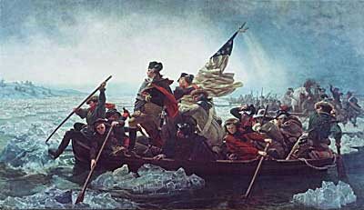
The ideas of 18th-century philosophes inspired the Founding Fathers to revolt against what they perceived as unfair British taxation. Washington Crossing the Delaware is one of the most famous depictions of the American Revolution.
One of the first philosophes was _________________________, an Englishman who concluded in his famous book, LEVIATHAN, that people are incapable of ruling themselves, primarily because humans are naturally self-centered and quarrelsome and need the iron fist of a strong leader. Later philosophes, like _______________________, Montesquieu, and Rousseau were more optimistic about democracy. Their ideas encouraged the questioning of absolute monarchs, like the Bourbon family that ruled France. __________________________ suggested a separation of powers into branches of government not unlike the system Americans would later adopt. They found eager students who later became the founders of the American government.

John Locke
The single most important influence that shaped the founding of the United States comes from ______________________, a 17th century Englishman who redefined the nature of government. Although he agreed with Hobbes regarding the self-interested nature of humans, he was much more optimistic about their ability to use reason to avoid tyranny. In his SECOND TREATISE OF GOVERNMENT, Locke identified the basis of a legitimate government. According to Locke, a ruler gains authority through the consent of the governed. The duty of that government is to protect the natural rights of the people, which Locke believed to include _____, _____, and ______. If the government should fail to protect these rights, its citizens would have the right to overthrow that government. This idea deeply influenced _________________ as he drafted the ___________________________.

Important English Documents
Ironically, the English political system provided the grist for the revolt of its own American colonies. For many centuries English monarchs had allowed restrictions to be placed on their ultimate power. The ________________, written in 1215, established the kernel of limited government, or the belief that the monarch's rule was not absolute. Although the document only forced ______________ to consult nobles before he made arbitrary decisions like passing taxes, the Magna Carta provided the basis for the later development of _______. Over the years, representative government led by a ______________ came to control and eventually replace the king as the real source of power in Britain.
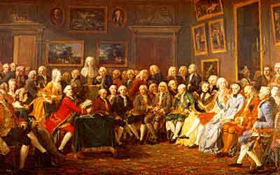
The ideas of the French Enlightenment philosophes strongly influenced the American revolutionaries. French intellectuals met in salons like this one to exchange ideas and define their ideals such as liberty, equality, and justice.
________________ (1628) extended the rights of "commoners" to have a voice in the government. The ___________________ (1688) guaranteed free elections and rights for citizens accused of crime. Although _______________ still had some real power in 1776, Britain was already well along on the path of democracy by that time.
The foundations of American government lie squarely in the 17th and 18th century European Enlightenment. The American founders were well versed in the writings of the philosophes, whose ideas influenced the shaping of the new country. Thomas Jefferson, George Washington, James Madison, and others took the brave steps of creating a government based on the Enlightenment values of liberty, equality, and a new form of justice. More than 200 years later, that government is still intact.

2a. The Colonial Experience
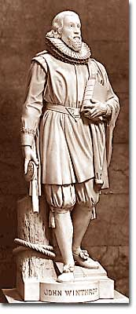
John Winthrop was the governor of the Massachusetts Bay Colony, one of the eight colonies governed by royal charter in the colonial period.
They created and nurtured them. Like children, the American colonies grew and flourished under British supervision. Like many adolescents, the colonies rebelled against their parent country by declaring independence. But the American democratic experiment did not begin in 1776. The COLONIES had been practicing limited forms of self-government since the early 1600s.
The great expanse of the Atlantic Ocean created a safe distance for American colonists to develop skills to govern themselves. Despite its efforts to control American ______, England could not possibly oversee the entire American coastline. Colonial merchants soon learned to operate outside British law. Finally, those who escaped religious persecution in England demanded the freedom to worship according to their faiths.

Colonial Governments
Each of the thirteen colonies had a charter, or written agreement between the colony and the king of England or Parliament. _______________ of royal colonies provided for direct rule by the king. A _________________ was elected by property holding males. But governors were appointed by the king and had almost complete authority — in theory. The legislatures controlled the salary of the governor and often used this influence to keep the governors in line with colonial wishes. The first colonial legislature was the ____________________________________, established in 1619.
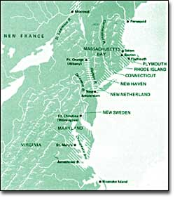
The colonies along the eastern coast of North America were formed under different types of charter, but most developed representative democratic governments to rule their territories.
When the first ________________ voyaged to the New World, a bizarre twist of fate created a spirit of self-government. These Pilgrims of the Mayflower were bound for Virginia in 1620, but they got lost and instead landed at _______ in present-day Massachusetts. Since Plymouth did not lie within the boundaries of the Virginia colony, the Pilgrims had no official charter to govern them. So they drafted the ______ _______, which in essence declared that they would rule themselves. Although Massachusetts eventually became a royal colony, the Pilgrims at Plymouth set a powerful precedent of making their own rules that later reflected itself in the town meetings that were held across colonial New England.

Trade and Taxation
Colonial economies operated under ____________, a system based on the belief that colonies existed in order to increase the mother country's wealth. England tried to regulate trade, and forbid colonies from trading with other European countries. England also maintained the right to tax the colonies. Both TRADE and __________ were difficult for England to control, and so an informal agreement emerged. England regulated trade but allowed colonists the right to levy their own taxes. SMUGGLERS soon exploited the English inability to guard every port by secretly trading against Parliament's wishes.
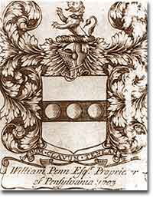
A proprietary charter allowed the governor of the colony to rule with great power over his lands. In William Penn's Pennsylvania, that power was used to establish a land of religious tolerance.
This delicate agreement was put to test by the _______________________. The war was expensive, and from the British point of view, colonists should help pay for it, especially considering that England believed it was protecting the colonists from French and Indian threats. The new taxes levied by the Crown nevertheless horrified the colonists. British naval measures to arrest smugglers further incited American shippers. These actions served as stepping stones to the Revolution.

Religious Freedom
Religious freedom served as a major motivation for Europeans to venture to the American colonies. Puritans and Pilgrims in Massachusetts, ______________ Pennsylvania, and Catholics in Maryland represented the growing RELIGIOUS DIVERSITY in the colonies. Rhode Island was founded as a colony of RELIGIOUS FREEDOM in reaction to zealous Puritans. As a result, many different faiths coexisted in the colonies. This variety required an insistence on freedom of religion since the earliest days of British settlement.
So the colonial experience was one of absorbing British models of government, the economy, and religion. Over the course of about 150 years, American colonists practiced these rudimentary forms of self-government that eventually led to their decision to revolt against British rule. The democratic experiment of American self-rule was therefore not a sudden change brought about by the Declaration of Independence. By 1776, Americans had plenty of practice.

2b. Independence and the Articles of Confederation
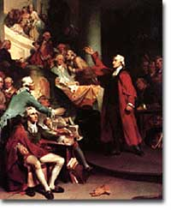
"Give me liberty, or give me death!" Patrick Henry's oratory against British taxation of American colonies was key in inspiring the Founding Fathers to declare independence.
"No taxation without representation!"
"These are the times that try men's souls."
"Give me liberty or give me death!"
All are famous phrases that sparked the __________ __________. In the view of many colonists, British rule suppressed political, economic, and religious freedoms. Many of those that hesitated to support independence were soon convinced by the passionate words of _____________, _____________, _________________, and eventually______________ and Thomas Jefferson. The Declaration of Independence in 1776, the American Revolution, and the creation of the Articles of Confederation represent the American colonies' first attempt to become a nation. This incubation was tentative at best, but ultimately led to success.

The Declaration of Independence
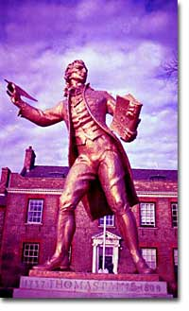
Thomas Paine advocated the independence of the American colonies from Britain. The writings of Paine, Samuel Adams, and others convinced Americans to set up their own state and democratic government.
As tensions between Britain and the American colonies increased, a series of meetings were called, including that of the _____ ______ _______ (1775-1776.) On July 4, 1776, the delegates approved the Declaration of Independence, the event that marks the birth of the United States. Thomas Jefferson, a delegate from Virginia, drafted the document primarily as a list of grievances against the king. His most important words, however, clearly shaped the philosophical basis of the new government. The famous introduction clearly reflected John Locke's _______ _________ ________: "...to secure these rights [Life, Liberty, and the pursuit of happiness], Governments are instituted among men, deriving their just powers from the consent of the governed." Jefferson further reasoned that since the British government had abused these rights, the colonists had the right "to alter or to abolish it, and to institute new Government."

The American Revolution and the Articles of Confederation
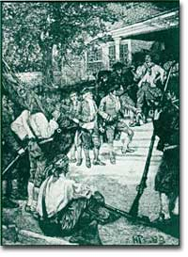
Shay's Rebellion showed the weaknesses of the Articles of Confederation. When the central government couldn't put down the rebellion, the first stirrings of federalism began to gather strength.
The British, of course, did not recognize the Declaration and continued to send troops to contain the rebellion. The war continued until 1783, so the new government had to be put in place in a wartime atmosphere. The Articles of Confederation, a compact among the thirteen original states, was written in 1776 but not ratified by the states until 1781. The loose "LEAGUE OF FRIENDSHIP" that it created reflected the founders' reaction to the central authority of King George III.
The government gave most powers to the states, and the central government consisted only of a legislature. Above all, the colonists wanted to preserve their liberties, but the central governments' lack of power proved to be disastrous. It could not regulate trade or keep the states from circulating their own currency. No chief executive could make real decisions, and no national court could settle disputes among states. And perhaps most importantly, they could not efficiently conduct a war nor pay the debts incurred once the war was over.
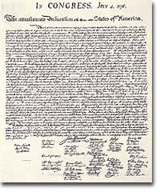
The Declaration of Independence reflected many of the ideals that the signers believed in. Ideas such as life, liberty, and the pursuit of happiness were products of the Enlightenment.
By 1786 the new country was in serious economic straits, and states were quarreling over boundary lines and tariffs. An economic depression left not only states in trouble, but also many ordinary citizens, such as farmers and merchants, were deep in debt as well. __________ ____________, a revolt by angry farmers in Massachusetts, symbolized the chaos in the country. Even though the Massachusetts militia finally put the rebellion down, it pointed out the inability of the central government to maintain law and order. In reaction, __________ ______________ of New York initiated the organization of a meeting in Philadelphia in 1787. This convention would eventually throw out the Articles of Confederation and draft the Constitution.
So the freedom that the American Revolution sought to preserve proved to create a government under the Articles of Confederation that could not keep law and order. But the failure of the initial experiment helped the founders to find a more perfect balance between liberty and order in the Constitution they produced in 1787.

