The Allied Victory in WWI

German War Plan
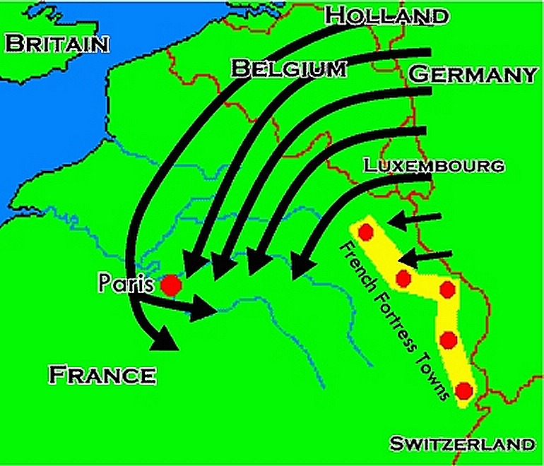

Schlieffen Plan
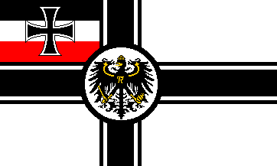
Germany was faced with a ______________________ war in 1914, with Russia to the east and France to the west.

German army general _____________________ organized a battle plan designed to take on both France and Russia.

The idea was to quickly defeat ________ first, and then defeat the __________.

German generals predicted Russia would be slow to ________________ due to a lack of industrialization and a shortage of _______________.

In order for the Schlieffen Plan to work, German armies had to march through neutral _____________, which was protected by ________________________.

The Plan in Action
Once ___________ invaded Belgium, Great Britain declared war.

Just as planned, Germany swept through Belgium. However, ______________ mobilized much quicker than expected.

To fight the Russians, Germany had to ____________ some of its forces to the east, which weakened their forces on the _________________ front.
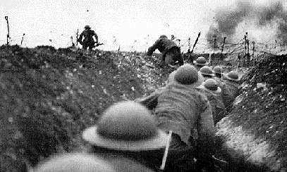
When British forces arrived in France the German drive to Paris ________________, and both sides dug in for winter.

The remaining four years of war would be a ____________ on the western front, fought in the _______________.

Costly Battles
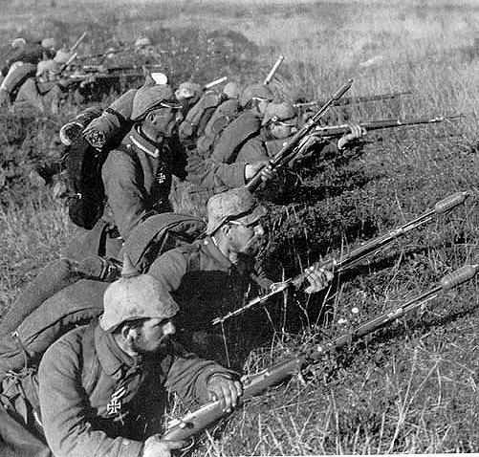

Tannenberg, 1914
At the start of the war the Russians speedily drove into Germany from the east, but suffered a crippling defeat at _________________________.

Russian soldiers were often sent into battle without _________ or _____________________, and over a million Russians were killed.

Verdun, 1916
The Germans tried to overwhelm the French at ___________, but failed.

The Somme, 1916
At the ______________ River the British lost 60,000 soldiers in one day.

By the time the month-long battle was over _________________ soldiers had died, with the Allies only gaining around 10 miles.

The Tide Turns


Russian Revolution
Due to horrible military defeats, hunger and chaos within Russia, a communist _____________________ occurred against the Czar in 1917.

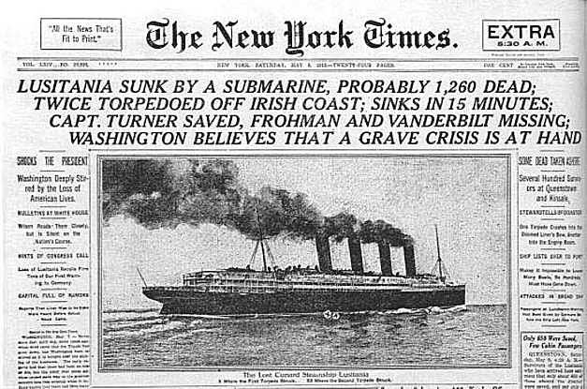
Communist leader _____________________________ pulled Russia out of the war, which greatly upset the other Allies.

America Joins
Soon later in 1917, the ________________ United States declared war on Germany for several reasons:

- Lusitania – The Germans sunk the large ocean liner, and did not halt ________________ submarine warfare.

- Cultural Ties – the US had more similarities with the Allies than with the Central Powers (language, traditions, and ____________________).

- Zimmermann Note – the British intercepted a message from Arthur Zimmermann, the German foreign minister, to his ambassador in _________.

Zimmermann asked for Mexican _________________, and promised that in return Germany would help Mexico conquer New Mexico, Texas, and Arizona.

Germany Defeated

Germany Falls
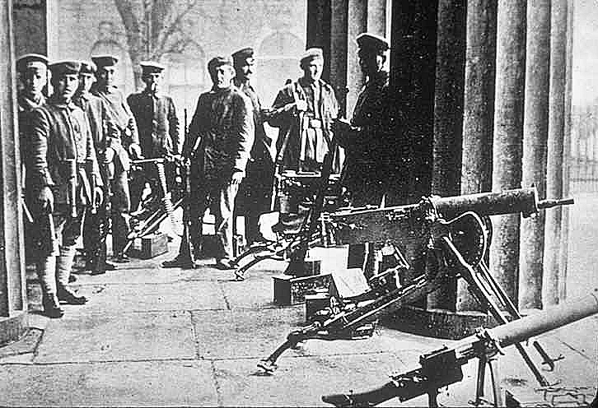
In 1918 the Allies slowly pushed the Germans back, who were _____________ of men and materials.

The German people, hungry and without work, ______________ against the Kaiser, who fled into exile.

The new German government was _____________________, and sought an ___________________, or agreement to stop fighting. World War I was over.

