Tomlin 2014

WORLD HISTORY MSL REVIEW

DIRECTIONS: Answer all the questions in the study guide and study before the MSL.

1. One reason for the development of an early civilization in the Tigris-Euphrates river valleys was that

1. the location protected the people from land invasion
2. periodic flooding left rich soil, which was ideal for farming
3. these rivers provided a direct trade route between Europe and Asia
4. these rivers flowed into the Mediterranean Sea

2. The early civilizations of the Nile River Valley, Mesopotamia, and the Yellow River Valley were similar because they were

1. industrialized societies
2. monotheistic
3. dependent on fertile land
4. dependent on each other for trade

3. One way in which the civilizations of the Sumerians, the Phoenicians, and the Maya were similar is that each

1. developed extensive writing systems
2. emphasized equality in education
3. established monotheistic religions
4. encouraged democratic participation in government

4.The Ancient Athenians are credited with

1. inventing and using the wheel
2. eliminating slavery
3. establishing governments that had democratic elements
4. inventing the printing press

5. Which ancient civilization established the basis of western democracy?

1. Phoenician
2. Egyptian
3. Sumerian
4. Greek

******BE ABLE TO PROVIDE INFLUENCES THAT GREECE AND ROME WOULD LEAVE FOR FUTURE GENERATIONS**********************

6. If a seignior (noble) has knocked out the tooth of a seignior of his own rank, they shall knock out his tooth. But if he has knocked out a commoner’s tooth, he shall pay one-third mina of silver.”

-Code of Hammurabi

7. Which idea of Babylonian society does this portion of the Hammurabi code of law reflect?

1. all men were equal under the law
2. fines were preferable to corporal punishment
3. divisions existed between social classes
4. violence was always punished with violence

8. Which of the following represents one of Justinian’s positive accomplishments?

the rebuilding of Rome

the conquest of Gaul

systematizing the Roman legal code

banning prostitution within the Byzantine Empire

9.The first known body of formal written law, which recorded and standardized existing laws in Babylonia, is known as the

Justinian Code.

Twelve Tables.

Code of Hammurabi.

Code of Babylonia.

**BE SURE TO GOOGLE AND GIVE A BRIEF SUMMARY AND EXAMPLE OF EACH**

1. Theocracy
2. Democracy
3. Oligarchy
4. Tyranny
5. Aristocracy
6. Draco
7. Hammurabi
8. Justinian law code
9. Judaism
10. Christianity Crusades Charlemagne
11. Islam Sunni/Shiites Muhammad Koran
12. Buddhism
13. Which example from the classical world best characterizes the principle of cultural diffusion?
    1. Preference for silk garments among the Roman elite
    2. Victory of Sparta in the Peloponnesian War
    3. Conversion of Asoka to Buddhism
    4. Growing influence of Confucianism in China during the Han dynasty

*************BE ABLE TO EXPLAIN WHAT THE COLUMBIAN EXCHANGE, TRIANGULAR TRADE, AND MIDDLE PASSAGE WAS AND THE IMPACT IT WOULD HAVE ON SLAVES****************************

11.The Native American population of Mexico in 1492 has been estimated at 25 million; the population in 1608 has been estimated at 1.7 million. This decrease in population was mainly a result of

1. crop failures brought on by poor weather conditions
2. emigration of Native Americans to Europe and Africa
3. wars between various native groups
4. diseases introduced by the Spanish

12.In Latin America during the early period of Spanish colonialism, the deaths of large numbers of the native people led to

1. a decline in Spanish immigration to the Americas
2. the removal of most Spanish troops from the Americas
3. the importation of slaves from Africa
4. improved health care in the colonies

13. What was the impact of the slave trade on Europeans sent to Africa?

A) Most died of tropical diseases.

B) Europeans established wealthy colonies that expanded through the nineteenth century.

C) Europeans rapidly were dispersed throughout the African nations of the interior, frequently intermarrying with the native population.

D) Europeans sent to Africa often remained for many years, absorbing the African cultures.

E) A new culture was produced through syncretism and it was transmitted to Europe by those returning.

14.Which of the following was not part of the system of "triangular trade"?

A) Shipment of slaves to the Americas

B) Exportation of European manufactured goods to Africa

C) Shipment of North American manufactured products to the Caribbean

D) Transport of plantation products to Europe

E) Use of slaves in the Caribbean

15.The "Middle Passage" referred to

A) the journey from captivity to the coastline of Africa.

B) the sale of slaves in the Americas and subsequent transportation to plantations.

C) the group of slaves permanently in rebellion in Suriname.

D) the voyage from Africa across the Atlantic to the Americas.

E) the existence of a slave prior to the inevitable attempt to escape.

************EXPLAIN THE IMPACT THAT THE ERUOPEANS WOULD HAVE ON THE SLAVES AND NATIVE AMERICANS

16.The Magna Carta, the Glorious Revolution, and the writings of John Locke all contributed to Great Britain’s development of

1. absolute monarchy
2. ethnic rivalries
3. parliamentary democracy
4. imperialist policies

17.In the American political context, John Locke's conception of inalienable rights and the legitimacy of the social contract found its most explicit statement in

A) the Mayflower Compact.

B) the Declaration of Independence.

C) the Magna Carta.

D) the U.S. Constitution.

E) The Federalist Papers.

18.Which phrase describes Magna Carta (1215)?

A. a church document describing English feudal society

B. a list of all the nobles in feudal England and their land holdings

C. a statement of grievances by English serfs sent as a petition to the king

D. a written agreement between the English king and his nobles establishing important individual rights

19.The Enlightenment influenced revolutionary thought by

1. Encouraging the poor to take up arms
2. Stressing the importance of the monarchy
3. Designing a common revolutionary strategy
4. Instilling a belief in the natural rights of man

20.The Declaration of Independence states, “That whenever any form of government becomes destructive of these ends, it is the Right of the People to alter or abolish it.” These words describe the enlightened idea of a

1. Need to ensure a representative government
2. Return to a society that has no central authority
3. Social contract between government and the people
4. Revolutionary intent to overthrow the current government

21.The American Revolution was motivated by the Enlightened idea

1. Of a distinct class system
2. That all men are created equal
3. Of the rightful rule of a monarch
4. That government needs central authority

22.The American Revolution and French Revolution were similar in that both

1. Were encouraged by Enlightenment idea of natural rights
2. Sought to limit the participation of people in government
3. Supported the theory of divine right
4. Increased the influence of religious institutions in government

*If man in the state of nature is free, and lord of his own possessions, why will he give up his freedom? The answer is that right in the state of nature are constantly exposed to attack by others. Hence each man joins in society to preserve his life, liberty, and property. Whenever the ruler endeavors to take away the property of the people, or reduce them to slavery…they are removed from any further obedience and left to…rise up with force and violence.”*

*-John Locke,*

*The Second Treatise of Government* (1690)

23. The ideas expressed by Locke in this passage helped inspire the

1. Theory of Divine Right
2. American Revolution
3. Separation of church and state
4. Industrial Revolution

24.The discoveries of Isaac Newton had a major influence on Enlightenment thinkers. In what way was this influence so significant?

1. Enlightenment thinkers attempted to base their philosophies on religious tradition
2. Enlightenment thinkers studied Newton’s writings about the freedom of human beings and the proper role of kings and governments
3. Enlightenment thinkers employed Newton’s scientific method when exploring questions about human nature and the responsibilities of the citizen
4. Enlightenment thinkers looked to the works of Copernicus and Galileo, as Newton had, when seeking answers about the nature of art and religion

We hold these truths to be self-evident: that all men are created equal, that they are endowed by their creator with certain unalienable rights, that among these are life, liberty, and the pursuit of happiness.”  
  
25.The ideas expressed in the quotation are based primarily on the writings of

1. Niccolo Machiavelli
2. Charles Darwin
3. Charlemagne
4. John Locke

***********BE ABLE TO EXPLAIN HOW THE ENLIGHTENMENT PERIOD WOULD AFFECT SOCIETY IN TERMS OF NEW IDEAS AND THEORIES***********

**BE SURE TO GOOGLE AND GIVE A BRIEF SUMMARY OF EACH**

1. Glorious Revolution
2. American Revolution
3. Russian Revolution
4. French Revolution
5. Russian Revolution
6. Haitian Revolution
7. Agricultural Revolution
8. Industrial Revolution Urbanization Growth of Middle Class

***************HOW WOULD AGRICULTURAL REVOLUTIONS CHANGE THE DAILY LIFE FOR PEOPLE IN EARLY HISTORY *****************************

26.Which statement reflects an argument of Enlightenment philosophers against the belief in the divine right of kings?

1. god has chosen all government rulers
2. independence is built by military might
3. a capitalist economic system is necessary for democracy
4. the power of the government is derived from the governed

27.Martin Luther’s Ninety-Five Theses were a call for

1. religious revolt against the German princes
2. reforms within the Roman Catholic Church
3. greater papal authority
4. crusades to spread Christianity

28.In Western Europe, a major immediate effect of the Reformation was a

1. renewed domination of the Catholic Church over the German states
2. greater tolerance of religions other than Christianity
3. decrease in educational opportunities for the middle class
4. decline in religious unity and in the power of the Catholic Church

29.During the Renaissance, which development contributed most to the Protestant Reformation?

1. interest in Ancient Greece and Rome
2. advances in mathematics and science
3. questioning of traditional authority
4. attention to realism and detail

30.Which was a result of the Protestant Reformation in Europe?

1. the Catholic Church accepted the dominance of the new Protestant religions in Italy, France, and Germany
2. Spain became a predominately Protestant nation
3. Catholic Church leaders refused to make any changes in church practices
4. the power of the Catholic Church in Europe was weakened

31.Which was a major result of the Reformation?

1. new Christian denominations emerged
2. religious teachings were no longer allowed in the universities
3. the Crusades were organized
4. the power of the Pope was strengthened

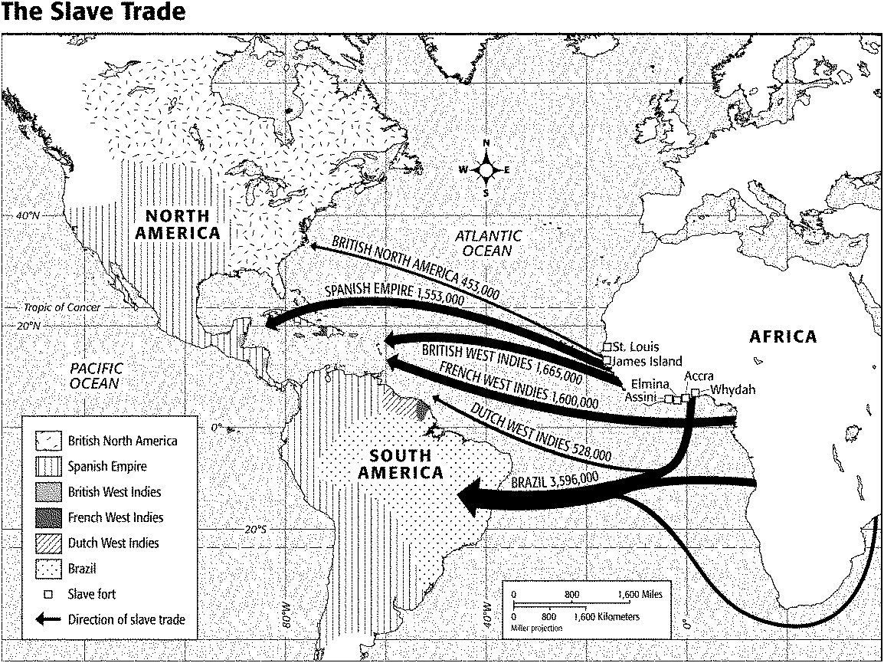

32. According to the map titled “The Slave Trade,” where were most slave forts located?

|  |  |  |  |
| --- | --- | --- | --- |
| a. | the Cape of Good Hope | c. | the Middle Passage |
| b. | the west coast of Africa | d. | Brazil |

33. According to the map titled “The Slave Trade,” the British imported approximately how many slaves to their colonies?

|  |  |  |  |
| --- | --- | --- | --- |
| a. | 1.7 million | c. | 3.6 million |
| b. | 2.1 million | d. | 9 million |

34. According to the map titled “The Slave Trade,” the greatest number of African slaves were taken to

|  |  |  |  |
| --- | --- | --- | --- |
| a. | British North America. | c. | the British West Indies. |
| b. | Brazil. | d. | the French West Indies. |

**“The stench of the hold. . . was so intolerably loathsome, that it was dangerous to remain there for any time. . . The closeness of the place, and the heat of the climate. . . almost suffocated us. . . The shrieks of the women, and the groans of the dying, rendered the whole scene of horror almost inconceivable.”**

**—Olaudah Equiano, *The Interesting Narrative of the Life of Olaudah Equiano*, 1789**

35. In the passage by Olaudah Equiano, he describes

|  |  |  |  |
| --- | --- | --- | --- |
| a. | plantation life. | c. | a slave ship. |
| b. | indentured servitude. | d. | an *encomienda*. |

**“THE COLUMBIAN EXCHANGE”**

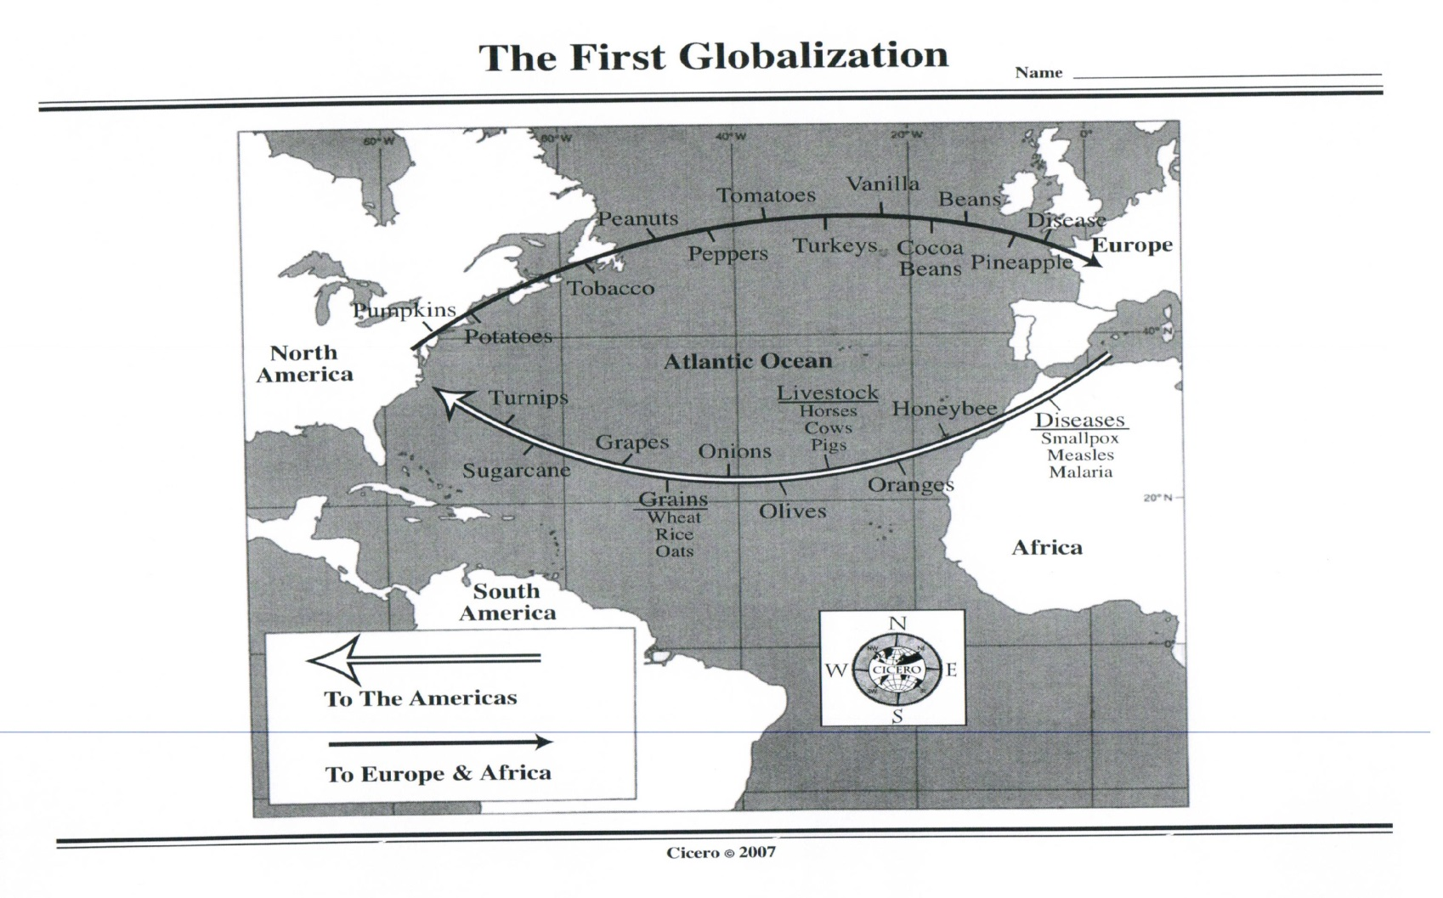

Whooping Cough

Influenza

***Directions:*** *Use the map to answer the following questions about the Columbian Exchange.*

36. What are three continents that were involved in the Columbian Exchange? ___________________________________

_________________________________________________________________________________________________

37. What is the main ocean that this exchange took place on? ________________________________________________

_________________________________________________________________________________________________

38. What diseases were sent over to the Americas? ________________________________________________________

_________________________________________________________________________________________________

39. What bird was shipped from the Americas to Europe? ____________________________________________________

40. List three types of livestock that were sent to the Americas: ______________________, ____________________, & _______________________.

41. What insect was brought to the Americas to pollinate crops? ______________________________________________

42. What addictive crop was sent from the Americas to Europe? ______________________________________________

43. List three types of grain that were sent to the Americas: ________________________, _____________________, & _______________________.

44. Goods going from the Americas to Europe were traveling in which direction? __________________________________

45. What were some of the advantages of the Columbian Exchange? _________________________________________

__________________________________________________________________________________________________________________________________________________________________________________________________

46. What were some disadvantages of the Columbian Exchange? ____________________________________________

__________________________________________________________________________________________________________________________________________________________________________________________________

“The Columbian Exchange”

J.R. McNeill

*The Columbian Exchange had dramatic and lasting effects on the world. New diseases were introduced to American populations that had no prior experience to them. The results were devastating. The populations were introduced to new weeds, pests, livestock, and pets. Native American populations had no immunity to these diseases and were stricken by wave and wave of epidemics, which produced a catastrophic mortality throughout the Americas. On some Caribbean islands, the Native American populations died out completely. In all, between 1492 and 1650, perhaps about 90% of the Native American population died.*

*When the first inhabitants of the Americas crossed the land bridge 20,000 years ago they brought few diseases with them. Why? For one reason, they had no domesticated animals. These domesticated animals were the original source of human diseases such as small pox and measles. In addition, the first Americans spent many years in the extreme cold, which eliminated many disease-causing agents.*

*On the other hand, the Columbian Exchange also introduced new foods and fiber crops improving diets and increasing trade. In addition, it also brought horses, cattle, sheep, goats, pigs, and a collection of other useful animals to the Americas. Of all the animals introduced by the Europeans, the horse held particular attraction. Native Americans encountered it as a “fearsome war beast”; however, they soon learned to ride and raise horses themselves. The introduction of the horse revolutionized hunting buffalo in the Great Plains. Eventually, cattle ranches became widespread. Ranching economies emerged throughout the Americas.*

**Directions: After reading the passage above, answer the following questions.**

|  |  |
| --- | --- |
| 47. The word “epidemic” is underlined in the passage. Using context clues, define epidemic in your own words. |  |
| 48. According to McNeill, what group of people suffered the most from the Columbian Exchange? Explain why. |  |
| 49. Why didn’t the original inhabitants in the Americas suffer from diseases? Explain. |  |
| 50. What were some positive outcomes from the Columbian Exchange? |  |
| 51. **OPINION:** After learning and reading about the Columbian Exchange, would you argue that the Columbian Exchange had more of a positive or negative effect on our world? *Make sure to explain and defend your answer with facts from the map and reading passage.* |  |

**Key Concepts:**

1. **Mercantilism**
2. **Economic theory and practice common in Europe from the 16th to the 18th century that promoted governmental regulation of a nation’s economy for the purpose of increasing state power at the expense of rival national powers]**
   1. **Precious metals, such as gold and silver, were considered essential to a nation’s wealth**
   2. **It was believed that trade balances must be “favorable,” meaning an excess of exports over imports**
   3. **Colonial possessions should serve as markets for exports and as suppliers of raw materials to the mother country**
   4. **Manufacturing was forbidden in colonies, and all commerce between colony and mother country was held to be a monopoly of the mother country.**
3. **Slavery**
4. **A condition in which one human being was owned by another.** 
   1. **A slave was considered by law as property, or chattel, and was deprived of most of the rights ordinarily held by free persons. ~ Britannica**

**Questions:**

* 1. **When was mercantilism an accepted economic practice? ________________________________________________________________________**
  2. **Where was mercantilism an accepted economic practice? ________________________________________________________________________**

1. **What did mercantilists consider essential to a nation’s wealth? ________________________________________________________________________**
2. **What is a favorable balance of trade? ________________________________________________________________________**
3. **According to mercantilists, what was the role of colonies? ________________________________________________________________________**
4. **What was forbidden in the colonies? ________________________________________________________________________**
5. **Who could colonies trade with? ________________________________________________________________________**
6. **Define monopoly. ________________________________________________________________________**
7. **Define slave. ________________________________________________________________________**
8. **How did a slave differ from a serf? (Previous knowledge) ________________________________________________________________________**
9. **The British system of mercantilism was opposed by many American colonists because it**
10. **placed quotas on immigration**
11. **discouraged the export of raw materials to England**
12. **placed restrictions on trading**
13. **encouraged colonial manufacturing**

**Historical Circumstances:**

**“Enslaved Africans first arrived in the colonies in the early 1600s. Mercantilism led to high demands for sugar, rice, tobacco, and cotton. Products sent from the colonies to the mother country could be sold in Europe for high profits. Enslaved Africans filled the endless demand for the cheap and plentiful labor supply needed to produce these goods. By 1750 there were over 200,000 enslaved Africans living in the 13 American colonies.**

**The slave trade routes of the early 1600s through the late 1700s resembled a triangle and came to be called the triangular trade. The triangle was formed with trade from Europe to the coast of Africa to the West Indies and back to Europe.**

**The Middle Passage was that corner of the triangle that involved the trade of enslaved Africans. Ships from Europe carried goods to Africa. There the products were exchanged for slaves. The enslaved Africans were transported to the West Indies where they were sold for up to $1,500 a person. The enslaved Africans would then be taken to the colonies, to Mexico, or to South America where they were once again sold.**

**With their profits, the slave traders purchased sugar and molasses, which were then taken back to Europe. Profits were to be made throughout the triangular trade. Merchants, slave traders, and shippers all shared in the profits at some point along the trade route.”**

**~ The American Journey**

**DIRECTIONS: Answer the following questions.**

**68. What was the Middle Passage?**

**____________________________________________________________________________________________________________________________________________________________**

**69.Why was the West Indies important to the workings of the Triangular Trade?**

**____________________________________________________________________________________________________________________________________________________________**

**70. Who benefited from the triangular trade? Who lost?**

**____________________________________________________________________________________________________________________________________________________________**

**One of the most important southern products was cotton. Cotton was a labor intensive crop, or one that required many people to grow and harvest it. Thus, continuation of the slave trade became necessary to the economy of the large cotton plantations. The southern economy grew through the importation of enslaved Africans and through an increase in the exportation of cotton.**

**In 1807 Congress passed the U.S. Law on Slave Trade, making it illegal to import enslaved Africans into the United States, but it did not entirely stop the slave trade. Soon traders found new overland routes into the country through Texas and Florida.**

**Directions: Use the graphs to answer the questions.**



**71. What was the trend in the importation of enslaved Africans between 1771 and 1860? ____________________________________________________________________________________________________________________________________________________________**

**72. What was the trend in cotton exportation between 1792 and 1820?**

**____________________________________________________________________________________________________________________________________________________________**

**73. What conclusion can be drawn about the 1807 U.S. Law on Slave Trade and the importation of enslaved Africans after 1808?**

**____________________________________________________________________________________________________________________________________________________________**

**74. What impact did the 1807 U.S. Law on Slave Trade seem to have had on the importation of enslaved Africans?**

**____________________________________________________________________________________________________________________________________________________________**

**75. What conclusions can you make about slavery and the southern economy?**

**____________________________________________________________________________________________________________________________________________________________**

**CRITICAL THINKING:**

**Drawing Conclusions:**

**Only 12 percent of all slaveholders had plantations with 20 or more enslaved Africans. Yet more than half of the enslaved Africans in the colonies lived on these plantations. What does this tell you about the organization of the South’s economy?**

**__________________________________________________________________________________________________________________________________________________________________________________________________________________________________________**

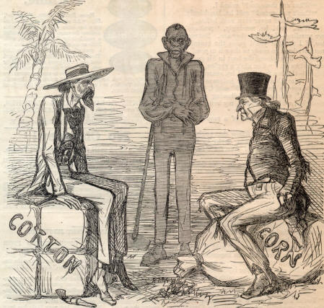**What does this illustration show about economic differences between the North and South?**

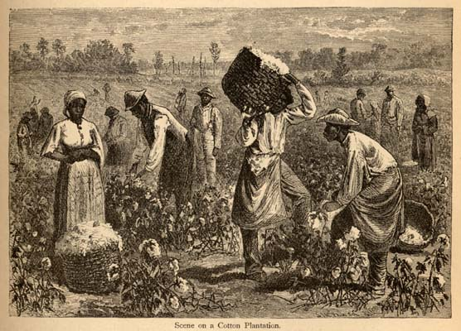

**What does this illustration reveal about labor and cotton plantations? ____________________________________________________________________________________________________________________________________________________________**

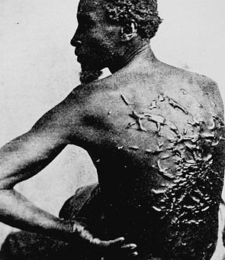

**What do you think happened to this individual? Why do you think this happened? ____________________________________________________________________________________________________________________________________________________________**

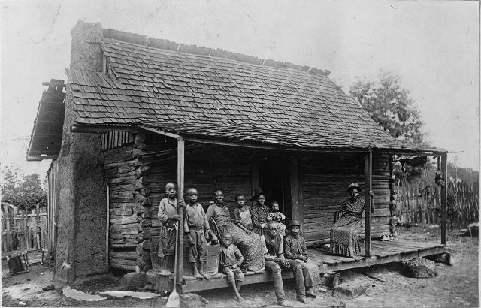

**What does this photograph reveal about the living conditions of slaves? ____________________________________________________________________________________________________________________________________________________________**

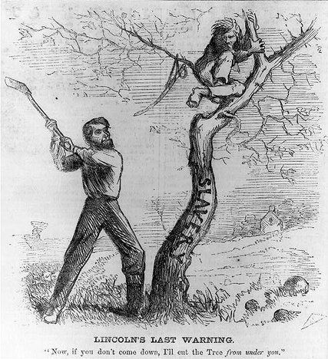**What is the meaning of the cartoon?**

Explain how this technological revolution would lead to the production of more food for the people in Europe

Three Field System

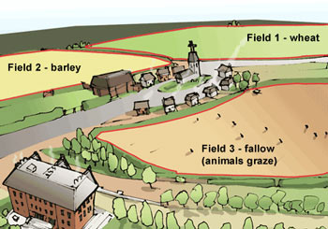

The Harness

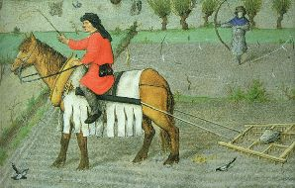

The Plow

**[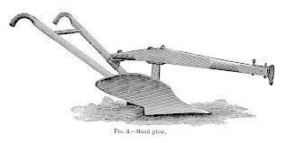](http://www.google.com/imgres?sa=X&biw=1366&bih=620&tbm=isch&tbnid=3B0FrSz-FnbiOM:&imgrefurl=http://www.worldsteel.org/steelstory/&docid=Wnmnt0kBPOmJJM&imgurl=http://www.worldsteel.org/steelstory/images/photos/deere-plow-19th-century-granger.jpg&w=900&h=452&ei=PqnOUuzsM4vfkQeChIGYAg&zoom=1&ved=0CMEBEIQcMCI&iact=rc&dur=2193&page=2&start=18&ndsp=28)**

76.After 1880, European nations sought colonies in Africa primarily because the Europeans were

1. in need of land for their surplus populations
2. competing of raw materials and markets
3. determined to bring Christianity to the Moslem world
4. interested in completing their geographic knowledge of the world

77.British control over South Africa, French control over Indochina, and Spanish control over Mexico are examples of

1. isolationism
2. appeasement
3. nonalignment
4. imperialism

78.In the past, European nations have conquered other lands, made them into colonies, and controlled their economies.  
  
79.Which term refers to the situation described in this statement?

1. socialism
2. isolationism
3. imperialism
4. monotheism

Take up the White Man’s burden—  
Send forth the best ye breed  
Go bind your sons to exile  
To serve your captives’ need;  
To wait, in heavy harness,  
On fluttered folk and wild—  
Your new-caught, sullen peoples,  
Half-devil and half-child.

--Rudyard Kipling, “The White Man’s Burden”

80.The phrase “White Man’s burden” in this excerpt refers to the

1. negative attitude of Europeans toward peoples of the non-Western world
2. advantages Europeans would gain by colonizing Africa, Asia, and Latin America
3. positive role of the Roman Catholic Church in Africa and Asia
4. challenges non-Europeans faced when trading with the Europeans

**. Make a guess: What is the 'scramble for Africa'?**

1. 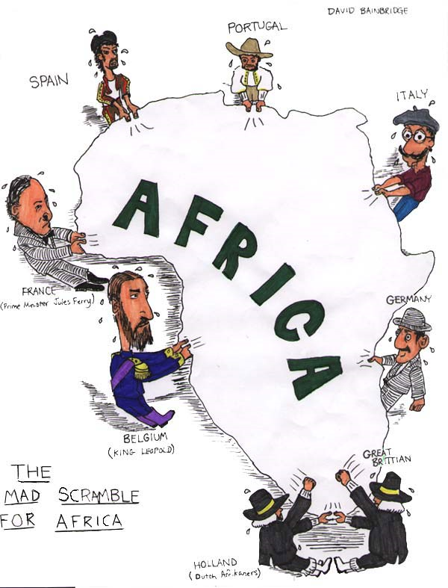

**81. According to the cartoon, which European countries were fighting for a position in Africa?**

1. **\*\*\*\*\*\*\*\*Know what British salt tax is**************** Google and give brief summary**

83.The Fourteen Points and the Atlantic Charter were both

1. statements of post-war goals for establishing world peace
2. plans of victorious nations to divide conquered territories
3. military strategies for defeating enemy nations
4. agreements between nations to eliminate further development of weapons

84.After World War I, the opposition of some Members of Congress to the Versailles Treaty was based largely on the idea that the Treaty

1. did not punish the Central Powers harshly enough
2. did not give the United States an important role in world affairs
3. would require the United States to join the League of Nations and might result in a loss of United States sovereignty
4. would require the United States to assume the cost of rebuilding the war-torn European economies

85.Which action best demonstrated the United States effort to isolate itself from European conflicts after World War I?

1. lowering tariff rates
2. attempting to improve relations with Asia
3. failing to sign international disarmament agreements
4. refusing to join the League of Nations

86.President Woodrow Wilson’s statement “The world must be made safe for democracy” was made to justify his decision to

1. end United States imperialism in Latin America
2. support tariff reform
3. send troops into Mexico to capture Pancho Villa
4. ask Congress to declare war against Germany

87.The demand for German war reparations by the European Allies helps to explain the failure of the peace settlement following

1. World War I
2. World War II
3. the Korean War
4. the Vietnam War

88.During World War II, women and minorities made economic gains mainly because

1. a shortage of traditional labor created new opportunities in the workplace
2. more educational opportunities increased the number of skilled workers in these groups
3. labor unions successfully demanded equal opportunities for these groups
4. new civil rights legislation forced businesses to change their hiring practices

89.A major cause of the internment of Japanese Americans during World War II was

1. national segregation policies
2. immigration quotas
3. racial prejudice
4. economic depression

90.President Harry Truman’s decision to use atomic bombs against Japan was primarily based on his belief that

1. an invasion of Japan would result in excessive casualties
2. Germany would refuse to surrender in Europe
3. an alliance was developing between Japan and the Soviet Union
4. Japan was in the process of developing its own atomic weapons

91.President Harry Truman justified using atomic bombs on Japan in 1945 on the grounds that the

1. world was ready for a demonstration of nuclear power
2. Axis powers deserved total destruction
3. early ending of the war would save many lives
4. American public demanded that the bombs be used

92.The Japanese attack on Pearl Harbor in 1941 is an illustration of the

1. impact a single event can have on public opinion a time of crisis
2. effectiveness of a policy of appeasement in stopping aggression
3. success of the pacifist movement in the United States
4. role of communism as a negative influence in global affairs

**BE ABLE TO EXPLAIN HOW SOCIAL AND ECONOMIC CONDITIONS OF *COLONIAL RULE* CONTRIBUTED TO NATIONALIST MOVEMENTS IN THESE COUNTRIES**

1. India, who controlled them, why, how it led to above question
2. Africa, who controlled, several different countries,
3. Southeast Asia, Vietnam, Cambodia, Laos, who controlled, why, how it led to above question

**BE SURE TO GOOGLE AND GIVE A BRIEF SUMMARY OF EACH OF THESE TWENTIETH INTERNATIONAL CRISIS**

1. Berlin Blockade
2. Korean War
3. Hungarian Revolt
4. Cuban Missile Crisis
5. Iranian Revolt
6. Opec Oil Crisis- Embargo-Explain impact on international affairs
7. Israel –PLO Conflict
8. 911-Terrorism
9. Perestroika Glasnost and Mikhail Gorbachev

**BE SURE TO GOOGLE AND GIVE A BRIEF SUMMARY OF EACH**

1. International Space Station
2. Internet
3. Ozone Layer
4. Genetic Engineering
5. Cloning
6. Green Revolution
7. Global Economy
8. Free Trade NAFTA
9. Ozone Layer
10. Universal Declaration of Human Rights
11. Terrorism 911
12. Apartheid
13. Al Qaeda
14. Hamas
15. Hezbollah
16. Jihad
17. Climate Change, why it happens
18. Global warming, why it happens
19. Social networks

**READ THE PROMPTS AND ANSWER THE ESSAYS BASED ON WHAT THE QUESTION IS ASKING. USE THE RUBRIC AS A GUIDE. ANSWER ON SEPARATE SHEETS OF PAPER AND ATTACH TO THE STUDY GUIDE**