World History Name_____________________
Goal 1 Study Guide
Tomlin 2014
Multiple Choice Question:
1. Reason’s for the development of an early civilization in the Tigris-Euphrates river valley.

2. Characteristics of early civilizations that developed along the Nile, the Tigris-Euphrates and the Huang He (Yellow River) valleys.

3. The early civilizations of the Nile River Valley, Mesopotamia, and the Yellow River Valley.

4. Similarities of the civilizations of the Sumerians, the Egyptians, and the Chinese.

5. Hammurabi’s Code

6. Babylonian society

7. Polytheism

8. Monotheism

- Where did the earliest civilizations tend to develop?

- What region of the world saw the development of the earliest civilizations?

- Which of the following early river valley civilizations developed in the greatest state of isolation from the others?

- Early civilizations and writing

- Which of the following did ancient Egyptian, Shang and Sumerian civilizations all have in common?

.
Mesopotamia  Monotheism  Sumer  Cultural Diffusion  Cuneiform  Rivers  Polytheism  Pyramids  Gilgamesh Epic  Hammurabi Code  Mandate to Heaven  Mummification | Silt  City-states  Hieroglyphics  Theocracy  Ziggurat  Empire  Pharaoh  Dynasty  Fertile Crescent  Irrigation Ditches  Sail  Rosetta Stone  Feudalism

Document 1:
The Tigris-Euphrates River Valley Civilization/The Fertile Crescent
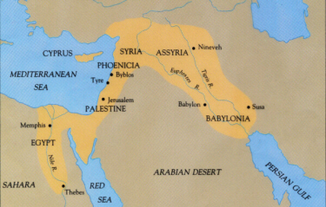

- Why is the area of the Tigris-Euphrates called the “Fertile Crescent?”

- Why was the Tigris and Euphrates Rivers important to ancient Sumerians?

- Explain the importance of the Nile River to ancient Egypt?

- How was life along the Yellow River both similar and different from life along the Nile River?

