World History
Tomlin

Enlightenment and Revolution Potential Test Questions

1.The ____________ _______________ involves, stating a problem, forming a hypothesis, making observations, and forming conclusions.
2. The belief that the sun revolves around the Earth is known as the
3. The Heliocentric theory states
4. Isaac Newton is credited for developing
5. Isaac Newton is famous for . .
6. Galileo
7. In his book Leviathan, who argued the people should give up their right to a strong ruler ?
8. Who argued for the natural rights of life, liberty and property ?
9. Philosophes who believe in no god were called
10. Who said “ I disagree with what you say, but I’ll defend to the death your right to say it”?
11. Frederick II of Prussia and Catherine the Great of Russia were examples of what ?
12. What Montesquieu idea is used in the US Constitution ?
13. The creator of Capitalism, the system of competition that the U.S., England, Germany and most countries use is. . . .
14. Who created the idea of a “Social Contract” that the power of the government comes from the people.
15. Which of the following stressed the use of experiments and observation in seeking knowledge?
16. Joseph II adopted Enlightenment ideas
17. The Declaration of Independence clearly reflects the ideas of
18. Which of the following was an effect of the printing revolution in the 1500s?
19. Which of the following helped Britain become a global power in the 1700s?
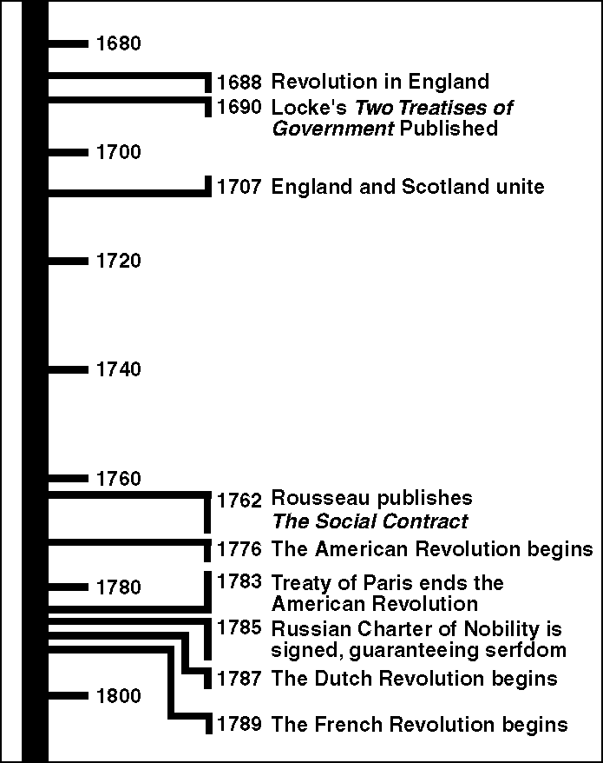

Figure 5-1
20. Which event in Figure 5-1 suggests that the American Revolution had a global impact?
21. According to Figure 5-1, how many years passed between the publication of Locke’s Two Treatises of Government and the end of the American Revolution?
22. According to Figure 5-1, in what year did the French Revolution begin?
23.Which event in Figure 5-1 best supports the generalization that Enlightenment reforms lagged behind in some parts of Europe?
24. An agreement by which people give up their natural state for an organized society
25. A way of explaining nature using observation and willingness to question accepted beliefs
26. Introduced a vaccine to prevent smallpox
27. A social gathering in which artists and thinkers exchange ideas
28. A grand and complex artistic style
29. According to Hobbes and Locke, human nature was governed by ____.
30. Life, liberty, and property are examples of ____.
31. All matter is made up of smaller particles was proven by
32. Joseph II was a(n) ____ because he used Enlightenment ideas to bring about political and social
change.

33. Until the Scientific Revolution, the traditional authorities wer

34. Who argued that people had a right to overthrow a government that does not protect their natural rights?

35. Which of the following phrases belongs in Step 5 in the chart titled “The Scientific Method”?
a. Observe the natural world. c. Answer the question.
b. Form a conclusion. d. Identify a problem.

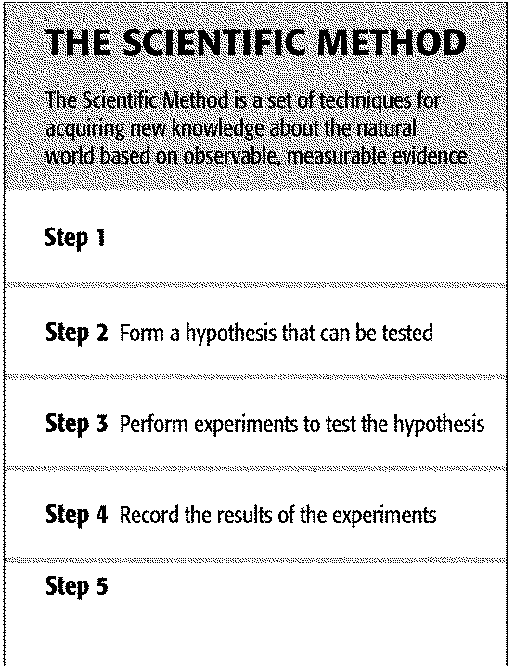

36. Which of the following phrases belongs in Step 1 of the chart titled “The Scientific Method”?
a. Answer a question. c. Perform experiments.
b. Identify a problem. d. Draw a conclusion.

“The state of nature has a law of nature to govern it. . . no one ought to harm another in his life, health, liberty, or possessions. . . Every one. . . may not. . . take away, or impair. . . the life, the liberty, health, limb, or goods of another.”
Two Treatises on Government, 1690

37. Who wrote the passage from Two Treatises on Government?
a. Thomas Hobbes c. Adam Smith
b. John Locke d. Isaac Newton

True/False
Indicate whether the statement is true or false.

38. John Locke believed that the purpose of government was to protect people’s natural rights.
39. Enlightenment ideals had little or no impact in the new nation known as the United States.
40. Kepler solved problems with Copernicus’s theories by showing that the planets orbited the sun in an ellipse, not a circle.
41. The Heliocentric theory, proposed initially by Copernicus, contends the the Earth is at the center of the solar system.
42. Galileo promoted the ideas put forth by Copernicus and later was forced by the Catholic Church to recant his work and spent the last years of his life under house arrest.
43. European monarchs who embraced Enlightenment ideals had no intention of giving up their own power.
44. Robert Boyle, often called the father of modern chemistry, was the first chemist to define an element and also described matter as a cluster of tiny particles.

Document Based Assessment
The Enlightenment

.
—John Locke, The Second Treatise of Civil Government, 1690

.
—Denis Diderot, Encyclopedia, 1752

.
—Samuel Adams, “The Rights of the Colonists,” 1772

45. What common idea do all three writers express?

46. How did Locke’s philosophy influence revolutionaries in France and the British colonies?

47. How did the United States incorporate the idea of natural law into its new form of government?

