Grinton Name__________________________________________________
World Studies One
HW C 2 S 1 Honors

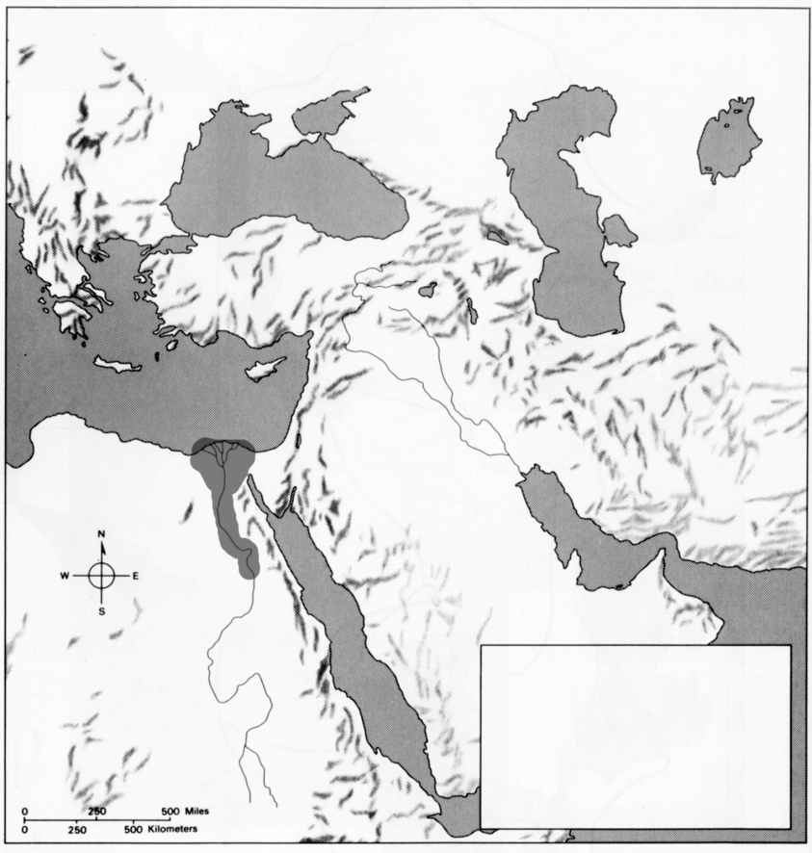
Label:

Nile River
Tigris River
Euphrates

Nile Delta
Egypt

Upper Egypt
Lower Egypt

Red Sea
Mediterranean Sea
Persian Gulf

1. Why was Egypt considered to be the “Gift of the Nile?”

2. What was the Egyptian religion like?

Who was their chief god?

3. What were the three periods of Egyptian history?

4. Why did the Egyptians build the pyramids?

Why was it important to the people to do this?

What people invaded Egypt and ended the Middle Kingdom?

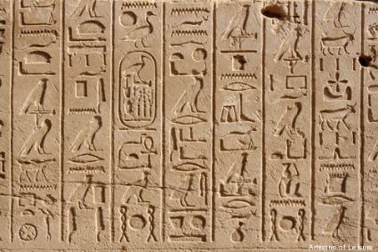
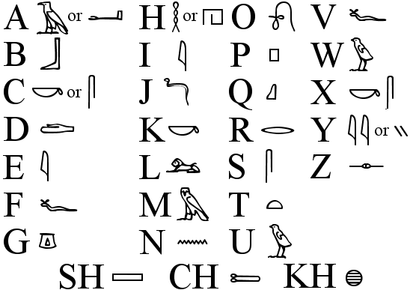
What was the importance of this innovation?

What type of language is this?

What advancements did the Egyptians make
In science and technology?

Are any of these advancements still influencing us today?

